Alexandre Passe-Coutrin

Homework 4

If we kill another broker, the last become a manager and the system is still running well

zookeeper start :
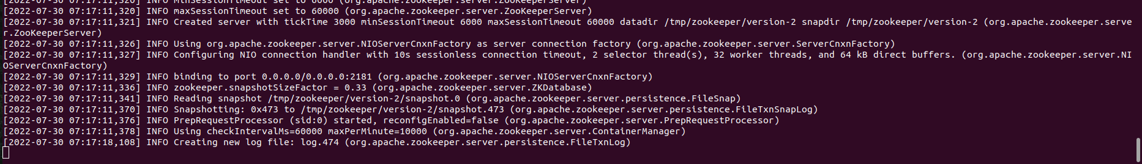
broker id=1
broker id=2
broker id=3
broker id=4
broker id=5
I create a topic(hw4) with 5 partition and 1 replication-factor
producer :
consumer :
we can see the consumer receive the message
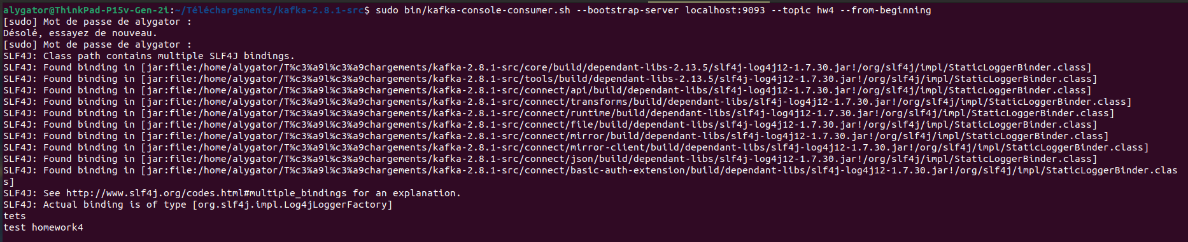
I killed broker1 and 2 :
Consumer continues to receive message from producer despite the error message that broker 1 and 2 is not working

